[ Insert official UPAEP logo ]
UPAEP · Decanato de Ingenierías
EVIDENCE — US01C-T1
Connect the login form to the authentication service
SmartGreenAI: Cilantro Crop

1. Task information
Task ID | US01C-T1
User Story | US-01-C — Complete secure login and role-based access
Sprint | Sprint 2 (2026-09-21 – 2026-10-09)
Week | Week 1
Responsible | Alexis Enrique Valle Parra
Peer reviewer | Jorge Velez Delgado
Planned / actual hours | 1 h / 1 h
Completed on | September 25, 2026
Status | Done

2. Task description
Connect the existing login screen to the backend. Passwords must be stored hashed (e.g., bcrypt) and a successful login must create a session or token (e.g., JWT) with an expiration time.

3. Completion conditions
✓ Condition 1: Login form sends credentials to the backend and receives a session/token.
How it was verified: The login page (public/index.html + public/js/pages/login.js) posts the credentials to POST /api/auth/login. The browser capture shows the request answered HTTP 200, the JWT stored in the session (eyJhbG…) and the redirection to the producer home page. The same call made directly against the API returns token_type Bearer and expires_in.
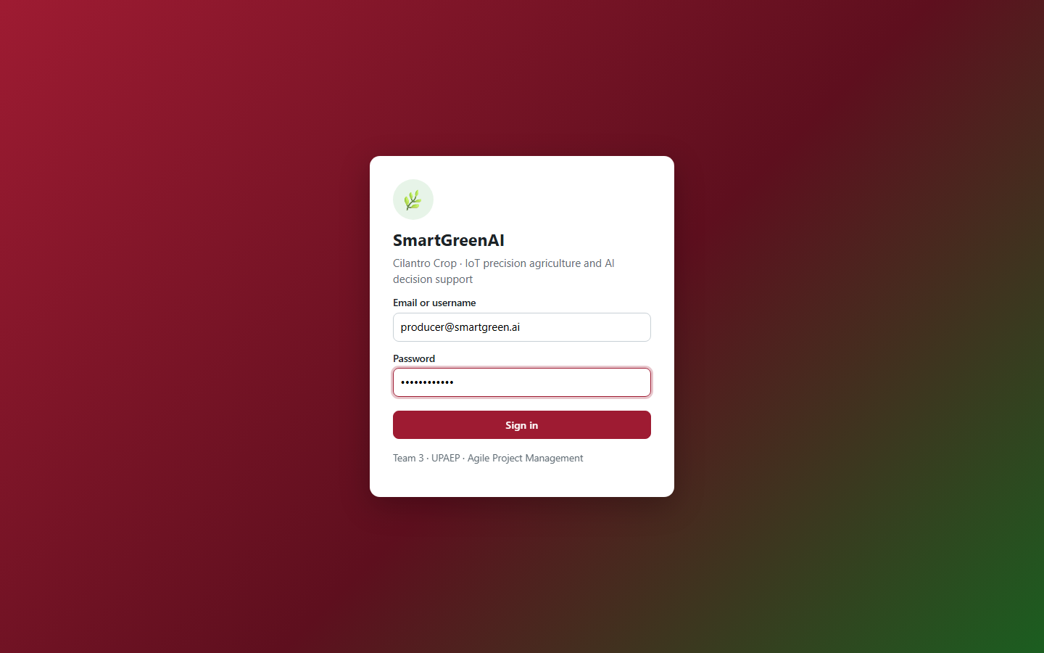
Figure US01C-T1-1. Login form of the web application with the credentials of a real user from the database (password masked by the browser). (US01C-T1_Connect_Login_Form_Authentication_Service_1.png)
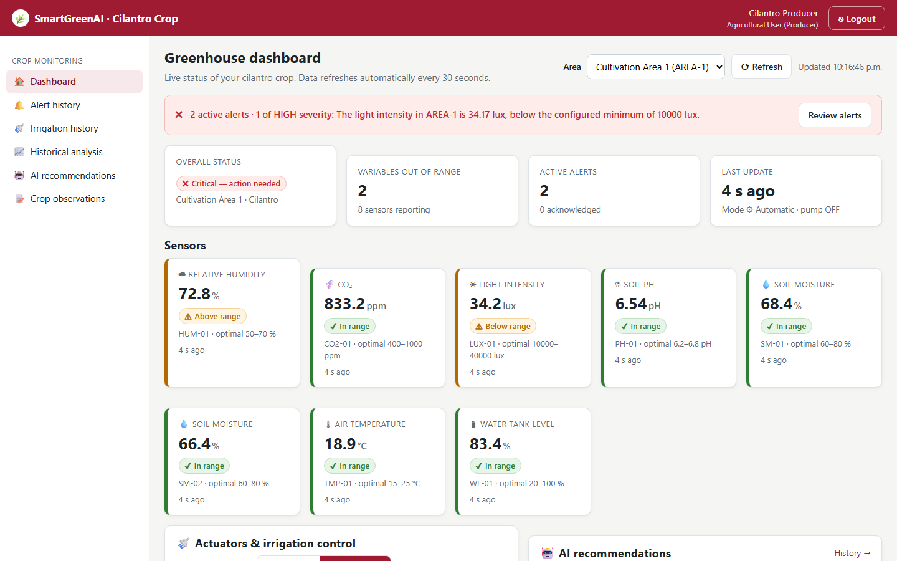
Figure US01C-T1-2. After a successful login the producer lands on the dashboard; the header shows the signed-in user and role. (US01C-T1_Connect_Login_Form_Authentication_Service_2.png)
POST /api/auth/login with a real user (token masked) (attached: US01C-T1_Connect_Login_Form_Authentication_Service_3.txt)
POST /api/auth/login
{
"email": "producer@smartgreen.ai",
"password": "********"
}
→ HTTP 200 OK (27 ms)
{
"access_token": "eyJhbG…",
"token_type": "Bearer",
"expires_in": 28800,
"user": {
"id": "usr-producer",
"email": "producer@smartgreen.ai",
"username": "producer",
"full_name": "Cilantro Producer",
"role": "Producer",
"organization_id": "org-team3"
}
}

public/js/pages/login.js — lines 23–43
form.addEventListener('submit', async (e) => {
e.preventDefault();
const email = form.email.value.trim();
const password = form.password.value;
if (!email || !password) { show('danger', '✖ Enter your email (or username) and your password.'); return; }
btn.disabled = true;
btn.textContent = 'Signing in…';
try {
const result = await api('/auth/login', { method: 'POST', body: { email, password } });
setSession(result.access_token, result.user);
const next = params.get('next');
location.href = next && next.startsWith('/') && !next.startsWith('//') ? next : (HOME[result.user.role] || '/');
} catch (err) {
// The API answers with a generic message: it never reveals whether the account exists.
show('danger', `✖ ${err.message}`);
btn.disabled = false;
btn.textContent = 'Sign in';
}
});

✓ Condition 2: Passwords are stored hashed (no plain text in the DB).
How it was verified: Passwords are hashed with bcrypt (cost 10) before being stored: the users table contains only 60-character $2a$/$2b$ hashes and no column holds the plain password. A query looking for the plain passwords returns 0 rows. Verification uses bcrypt.compare with a dummy hash for unknown users, so response times do not reveal whether an account exists.
Stored passwords (users table): only bcrypt hashes (3 rows; US01C-T1_Connect_Login_Form_Authentication_Service_4.csv)
email | role | password_hash | hash_length | is_bcrypt
admin@smartgreen.ai | Administrator | $2a$06$ZcSE5cpeeMplyF.PkGKTb.bGSKjqg8XJ3u4rNlig7LXpoNpH0JIzy | 60 | true
producer@smartgreen.ai | Producer | $2a$06$QC0RfH6OtUcggp/wIv0Gje5oZQkucE6y3BlKZOz/SNzg61vnPawtu | 60 | true
superadmin@smartgreen.ai | SuperAdministrator | $2a$06$Y6PcLNUxa7aNm5tQ.drXROiytU71z5B6boGkWHlyBsiJhNavzlULG | 60 | true
SQL: SELECT u.email, r.name AS role, u.password_hash, length(u.password_hash) AS hash_length, (u.password_hash LIKE '$2%') AS is_bcrypt FROM users u JOIN roles r ON r.id = u.role_id ORDER BY u.email
server/src/modules/auth/service.js — lines 19–46
async function login(email, password) {
const GENERIC = 'Invalid credentials.';
const user = await db.one(
`SELECT u.id, u.email, u.username, u.full_name, u.password_hash,
u.is_active, u.organization_id, u.role_id, r.name AS role_name
FROM users u
JOIN roles r ON r.id = u.role_id
WHERE lower(u.email) = lower($1) OR lower(u.username) = lower($1)`,
[email],
);
// Compare against a dummy hash when the user does not exist so the response
// time does not betray which emails are registered.
const hash = user ? user.password_hash : '$2a$10$invalidinvalidinvalidinvalidinvalidinvalidinvalidinvalidinv';
const passwordMatches = await bcrypt.compare(password, hash);
if (!user || !passwordMatches || !user.is_active) {
throw unauthorized(GENERIC);
}
await db.query('UPDATE users SET last_login = NOW() WHERE id = $1', [user.id]);
const { token, expiresInSeconds } = await issueToken(user);
return {
access_token: token,
token_type: 'Bearer',

✓ Condition 3: Session/token expires after the defined time.
How it was verified: The token is a JWT signed with HS256 whose expiry comes from security_settings.session_hours (8 h). The decoded token issued above has iat 1790655407 and exp 1790684207: exp − iat = 28800 s = 8 h, the same value returned as expires_in (28800). A token signed with the server secret but already expired is rejected with HTTP 401 and the message "The session has expired. Please sign in again.".
Session length configured in security_settings (1 rows; US01C-T1_Connect_Login_Form_Authentication_Service_6.csv)
id | session_hours | updated_at
security-default | 8 | 2026-09-29T04:16:35.799Z
SQL: SELECT id, session_hours, updated_at FROM security_settings
Decoded JWT payload (header.payload only; signature omitted)
{
"header": {
"alg": "HS256",
"typ": "JWT"
},
"payload": {
"sub": "usr-producer",
"email": "producer@smartgreen.ai",
"role": "Producer",
"role_id": "role-producer",
"org": "org-team3",
"iat": 1790655407,
"exp": 1790684207
}
}

Expired token → 401 (attached: US01C-T1_Connect_Login_Form_Authentication_Service_8.txt)
GET /api/auth/me
Authorization: Bearer eyJhbG…
→ HTTP 401 Unauthorized (6 ms)
{
"status": 401,
"code": "ERR_AUTH_REQUIRED",
"message": "The session has expired. Please sign in again.",
"details": []
}

✓ Condition 4: Evidence: Login works end-to-end with a real user from the database; screenshot of successful login and of the hashed password in the DB.
How it was verified: The login works end to end with the seeded user producer@smartgreen.ai stored in PostgreSQL: Figures 1–2 show the form and the dashboard after signing in, and the SQL result under condition 2 shows the bcrypt hash of the same user. The HTTP exchanges and query results are attached as files.

4. Attached files
- US01C-T1_Connect_Login_Form_Authentication_Service_1.png
- US01C-T1_Connect_Login_Form_Authentication_Service_2.png
- US01C-T1_Connect_Login_Form_Authentication_Service_3.txt
- US01C-T1_Connect_Login_Form_Authentication_Service_4.csv
- US01C-T1_Connect_Login_Form_Authentication_Service_5.sql
- US01C-T1_Connect_Login_Form_Authentication_Service_6.csv
- US01C-T1_Connect_Login_Form_Authentication_Service_7.sql
- US01C-T1_Connect_Login_Form_Authentication_Service_8.txt

5. Traceability
Related requirements | FR-01, FR-02, FR-03, NFR-03, NFR-04
Implementation | See docs/TRACEABILITY.md
Verification | See docs/TRACEABILITY.md

6. Sign-off
Role | Name | Date | Signature
Responsible | Alexis Enrique Valle Parra | September 25, 2026
Peer reviewer | Jorge Velez Delgado | September 25, 2026
Product Owner acceptance | Alexis Enrique Valle Parra | September 25, 2026
Approval record: Daily Meeting 2 of Sprint 2 (Monday, September 28, 2026): "Review of the Week 1 milestone: US-01-C closed, API specification (US08-T1) shared on Wednesday, ER diagram and payload format approved." Decision: the firmware obtains UTC by NTP and sends recorded_at in ISO 8601; the server also stores received_at.

